

VELALAR COLLEGE OF ENGINEERING AND TECHNOLOGY
(Autonomous)

Approved by AICTE, affiliated to Anna University, and Accredited by NAAC with ‘A+’ Grade

DEPARTMENT OF COMPUTER SCIENCE AND ENGINEERING
(Accredited by NBA)

AN INTERNSHIP REPORT

Submitted by

DHIVYALAKSHMI R (21CSR021)

in partial fulfillment of the requirements for the award of the degree of

BACHELOR OF ENGINEERING IN
COMPUTER SCIENCE AND ENGINEERING

MAY 2025



VELALAR COLLEGE OF ENGINEERING AND TECHNOLOGY
(Autonomous)

Approved by AICTE, affiliated to Anna University, and Accredited by NAAC with ‘A+’ Grade

DEPARTMENT OF COMPUTER SCIENCE AND ENGINEERING
(Accredited by NBA)

AN INTERNSHIP REPORT

Submitted by

DHIVYALAKSHMI R (21CSR021)

in partial fulfillment of the requirements for the award of the degree of

BACHELOR OF ENGINEERING IN
COMPUTER SCIENCE AND ENGINEERING

MAY 2025

VELALAR COLLEGE OF ENGINEERING AND TECHNOLOGY

(An Autonomous Institution Affiliated to Anna University)

DEPARTMENT OF COMPUTER SCIENCE AND ENGINEERING

BONAFIDE CERTIFICATE

This is to certify that the Internship Report entitled “EMBEDDED SYSTEMS”, in partial fulfillment of the requirements for the award of the Degree of BACHELOR OF ENGINEERING is a record of original training undergone by DHIVYALAKSHMI R (21CSR021) during the period from (20.02.2025) to (05.04.2025) of her study in the department of COMPUTER SCIENCE AND ENGINEERING, VELALAR COLLEGE OF ENGINEERING AND TECHNOLOGY and the report
has not formed the basis for the award of any Degree/Fellowship or other similar title to any candidate of any University.

FACULTY IN-CHARGE | HEAD OF THE DEPARTMENT
Ms. S. DEVISRI, B.E., M.E., | Dr. S. JABEEN BEGUM, M.E., Ph.D.,
Assistant Professor, | Professor and Head,
Department of Computer Science and Engineering, | Department of Computer Science and Engineering,
Velalar College of Engineering and Technology, | Velalar College of Engineering and Technology,
Thindal, Erode-638012. | Thindal, Erode-638012.

CERTIFICATE FROM THE INDUSTRY
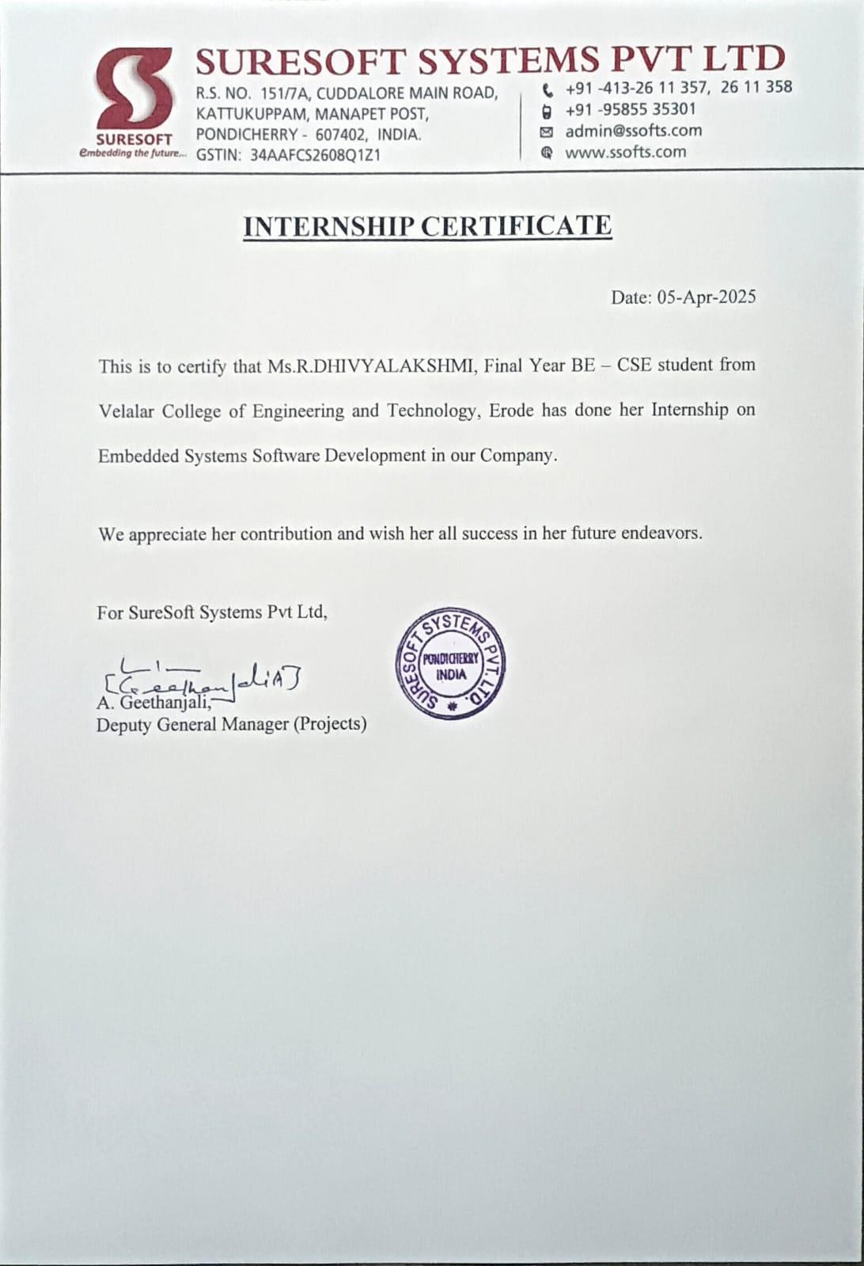

DECLARATION

I, DHIVYALAKSHMI R, hereby declare that the Internship Report, entitled “EMBEDDED SYSTEMS”, submitted to the Velalar College of Engineering and Technology in partial fulfillment of the requirements for the award of the Degree of Bachelor of Engineering is a record of original training undergone by me during the period (Feb-Apr 2025) and it has not formed the basis for the award of any Degree/Fellowship or other similar title to any candidate of any University.

Place: Signature of the Student

Date:

ACKNOWLEDGEMENT

On the occasion of successfully completing my internship project, I wish to express my heartfelt gratitude to the honorable Secretary and Correspondent of the Vellalar Educational Trust, Thiru. S. D. CHANDRASEKAR B.A., for providing the necessary infrastructure and support to accomplish for my internship.

I am deeply thankful to my Principal, Dr. M. JAYARAMAN Ph.D., of Velalar College of Engineering and Technology, for his continuous support and encouragement throughout my academic journey.

I would also like to express my sincere appreciation to my Dean, Prof. P. JAYACHANDAR M.E., for granting me the opportunity to undertake this internship and for his constant motivation.

My deepest gratitude goes to my Head of the Department, Dr. S. JABEEN BEGUM M.E., Ph.D., whose insightful guidance and encouragement helped me navigate through the various stages of this project.

A special thanks to my Internship Coordinator, Mr. N. MANICKA SENTHAMARAI, M.E., Assistant Professor, and my Internship Supervisor, Ms. S. DEVISRI B.E., M.E., Assistant Professor, for their technical guidance, timely suggestions, and unwavering support, which were instrumental in the successful completion of my internship project.

I also wish to extend my thanks to all the teaching and non-teaching staff members of the Computer Science and Engineering Department for their assistance.

TABLE OF CONTENTS

CHAPTER NO |  | TITLE | PAGE NO
 | BONAFIDE CERTIFICATE |  | (ii)
 | COMPANY CERTIFICATE |  | (iii)
 | DECLARATION |  | (iv)
 |  |  | (v)
 | ACKNOWLEDGEMENT
 | CONTENTS |  | (vi)
 | LIST OF FIGURES |  | (vii)
1 | ABSTRACT |  | 1
2 | INTRODUCTION ABOUT THE COMPANY |  | 2
3 | COMPANY PROFILE |  | 3
4 | INTERNSHIP OVERVIEW- WEEKLY REPORT |  | 5
 | 4.1 | DOMAIN OF TRAINING | 5
 | 4.2 | AIM & OBJECTIVES OF TRAINING | 7
 | 4.3 | SCOPE OF THE TRAINING | 8
 | 4.4 | TRAINING DETAILS | 9
5 | CONCLUSION |  | 15

LIST OF FIGURES

S.NO | FIGURE NO | CONTENTS | PAGE NO
1. | 4.1 | KEY COMPONENTS OF EMBEDDED SYSTEMS SOFTWARE | 5
2. | 4.4 | TV CHANNEL CONTROLLER CONSOLE OUTPUT | 13

CHAPTER 1 ABSTRACT
DEVELOPMENT OF A SOFTWARE-BASED TV CHANNEL CONTROLLER WITH PARENTAL LOCK FUNCTIONALITY
This report presents the software-centric development of a TV Channel Controller with Parental Lock Feature, designed to simulate basic Set-Top Box functionality using Embedded C programming. The project focuses on decoding IR remote control signals and executing corresponding channel switching operations, while integrating a security mechanism to restrict access to selected channels.
The core software modules include IR signal decoding (based on standard protocols like NEC), channel management, and a PIN-based parental lock system. The IR decoding is achieved through timer-based interrupt service routines that analyse the incoming pulse durations to determine valid remote commands. A mapping logic is implemented to associate decoded signals with channel operations, such as incrementing or decrementing the channel number.
To enhance user interaction, a PIN verification module is incorporated for restricted channels, prompting the user to enter a secure code before access is granted. The system’s layered software architecture cleanly separates the decoding logic, control logic, and display interface for maintainability and reusability. Real-time status updates and debugging support are enabled through UART communication.
This project provided valuable experience in interrupt-driven programming, real-time embedded software design, and protocol-level signal decoding. It reinforced the importance of writing structured, modular, and scalable code for embedded applications, especially those intended for consumer electronic systems like TVs and Set-Top Boxes.

Keywords:
Embedded C, IR Signal Decoding, NEC Protocol, Set-Top Box Simulation, Channel Switching, Parental Lock, Timer Interrupts, UART Debugging, Modular Software Design, Embedded Systems.

CHAPTER 2 INTRODUCTION ABOUT THE COMPANY
SURESOFT SYSTEMS PVT LTD is a pioneering embedded software development company focused on delivering innovative and high-quality solutions for Digital Consumer Products, including Set-Top Boxes (STB) and Smart TVs. With a strong emphasis on elegant and rich user interfaces, the company leverages industry-proven middleware platforms to bring robust, user- centric applications to global markets.
At the heart of SURESOFT’s operations lies its commitment to engineering excellence across multiple domains. The company specializes in developing iOS and Android-based mobile applications for managing and configuring server tools and consumer products, thereby ensuring seamless integration and enhanced user control. Furthermore, their expertise extends to building server-based software tools tailored for headend and factory operations, aiding in device provisioning, content generation, stream playout, and image programming.
SURESOFT SYSTEMS is also renowned for its Compliance Testing services, offering pre-certification and conformance testing tailored to meet market-specific regulations for digital consumer devices and mobile applications. This ensures that products meet the highest standards before reaching end users.
One of the company’s flagship offerings is its cost-effective DVB Middleware, a versatile solution developed over RTOS, Linux, and Android (ATV/AOSP) platforms. Deployed across a wide range of devices and silicon vendors worldwide, this middleware complies with diverse market and brand requirements while supporting multiple content delivery systems.
What sets SURESOFT apart is its vision of creating innovative, market-ready products with uncompromising quality. Their solutions are not only technically robust but also optimized for real-world operator and consumer environments. Through strategic partnerships with SoC and CAS partners, the company ensures compatibility, scalability, and security across its entire product lineup.
SURESOFT fosters a collaborative environment where creativity, technical mastery, and practical utility converge. The company is an ideal platform for interns and emerging professionals to explore the realms of embedded systems, mobile development, and digital media technologies, while contributing to products that shape the future of digital entertainment.

CHAPTER 3 COMPANY PROFILE
SURESOFT SYSTEM’S PVT LTD

SURESOFT is an industry-leading embedded software development company that delivers cutting-edge solutions for digital consumer electronics. Specializing in Set-Top Box (STB) and Smart TV products, the company focuses on integrating high-performance middleware with intuitive and elegant user interfaces. SURESOFT’s software is deployed globally, catering to diverse market and brand requirements, and ensuring robust functionality across a wide range of consumer devices.

Establishment:
SURESOFT SYSTEMS has established itself as a trusted name in embedded systems and digital consumer electronics. Headquartered in Pondicherry, the company has grown steadily by providing innovative, reliable, and scalable software solutions to top global clients and operators. Key Offerings:
- Embedded Software Development: Robust and scalable solutions for STBs and TVs using RTOS, Linux, and Android (ATV/AOSP) platforms.
- Mobile Applications: iOS and Android-based applications for controlling and managing consumer electronic products and server tools
- Headend and Server Tools: Backend software for device provisioning, GANG image burning, stream playout, and value-added service content creation.
- DVB Middleware: Cost-effective and highly compatible middleware solutions for DVB products, supporting a wide array of silicon vendors.
- Compliance and Conformance Testing: Market-specific testing services ensuring pre- certification and standard compliance for consumer devices and apps.

Company Values:
- Innovation in embedded systems and user experience design
- Excellence in product quality, deployment, and compliance
- Client-Focused approach with customized, scalable solutions
- Integration and Compatibility across platforms, devices, and delivery systems
- Global Reach with market-specific product

Company Information:
- Location: R.S.NO. 151/7A, Cuddalore Main Road, Kattukuppam, Manapet Post, Pondicherry - 607 402, India.
- Contact: Ph: +91-95855 35301, 0413-2611357 / 358, admin@ssofts.com

Specializations:
Embedded Systems, Middleware Solutions, Android TV Development, Mobile Application Development, Server Tools, Compliance Testing.

Work Culture:
SURESOFT fosters a dynamic and technically challenging work environment with a focus on creativity, collaboration, and technical rigor. The team operates within a structured workflow that includes agile methodologies, continuous integration practices, and collaborative project management. Interns and new professionals are integrated into live projects, working alongside seasoned developers and gaining hands-on experience in embedded systems, mobile development, and testing.

Technology Stack:
SURESOFT employs a sophisticated and embedded-oriented technology stack that includes:
  - Operating Systems: RTOS, Linux, Android (ATV/AOSP)
  - Programming Languages: C, C++, Java, Kotlin
  - Mobile Development: Android Studio, Xcode (iOS)
  - Middleware & Protocols: DVB, MPEG, CAS Integration
  - Backend Tools: Server-based provisioning systems, credential programming tools
  - Testing & Compliance: In-house conformance testing labs, market-specific compliance modules.

CHAPTER 4

INTERNSHIP OVERVIEW- WEEKLY REPORT

  - DOMAIN OF THE TRAINING

EMBEDDED SYSTEM SOFTWARE DEVELOPMENT AND REAL-TIME APPLICATION DESIGN
Embedded System Software Development is a specialized domain within computer engineering that focuses on designing and implementing efficient, low-level software for hardware-specific applications. Unlike general-purpose software, embedded software is developed for systems with specific functionalities, often operating under strict constraints related to memory, performance, and real-time responsiveness. This domain is particularly relevant in industries such as consumer electronics, automotive systems, medical devices, and industrial automation, where reliability and precision are critical.
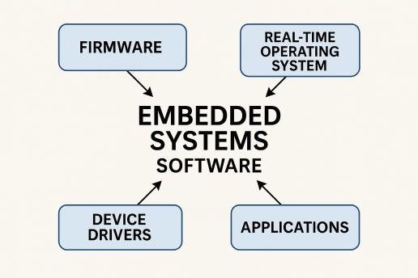

The training domain encompasses the following core components:

Microcontroller Programming and Embedded C:

A fundamental aspect of embedded systems involves programming microcontrollers to interface with various peripherals and execute application-specific logic. Using Embedded C as the primary language, I gained experience in writing structured, low-level code to control hardware components, manage digital I/O operations, and handle device-specific tasks. During the internship, I worked with microcontroller development environments, gaining proficiency in configuring ports, registers, timers, and interrupts to achieve real-time control.

Interrupt-Driven Programming:
Embedded systems often rely on interrupts to handle asynchronous events with minimal delay. I developed an in-depth understanding of how to configure and implement timer interrupts, external interrupts, and UART-based interrupts to respond to signals such as infrared (IR) input or user actions. These skills were vital for developing applications like IR signal decoders and channel controllers, where real-time response and low-latency processing are essential.

IR Signal Decoding and Protocol Implementation:

One of the key areas of focus was the decoding of IR remote signals based on standard communication protocols like NEC. This required capturing pulse durations, interpreting bit sequences, and translating them into actionable commands using timers and interrupt routines. I implemented signal mapping logic to associate decoded data with channel selection operations, gaining exposure to protocol-level communication and low-level signal processing.

Parental Lock and Access Control Systems:

I contributed to the design and implementation of a PIN-based parental lock mechanism within the channel controller project. This involved integrating secure input handling, PIN validation, and access control logic to restrict unauthorized channel access. This aspect of the training taught me the importance of user authentication in embedded applications and enhanced my ability to design layered control structures that ensure both functionality and security.

Simulation and Debugging Tools (Keil & Proteus):

Efficient debugging and simulation are critical in embedded software development. I acquired hands-on experience using Keil µVision IDE for code compilation and debugging, as well as Proteus for simulating hardware environments. These tools enabled me to validate system logic, test edge cases, and ensure that the software behaves reliably under simulated real-time conditions, reducing the gap between prototype and deployment.

UART Communication and Real-Time Monitoring:

To enable effective monitoring and debugging, I implemented UART (Universal Asynchronous Receiver-Transmitter) communication to transmit system status and logs in real-time. This skill allowed me to integrate serial communication into embedded projects, offering insights into the internal workings of the application during runtime and supporting diagnostics and evaluation.

Modular Embedded Software Design:
Throughout the internship, I followed best practices in modular programming, separating system layers into well-defined modules such as signal decoding, control logic, and user interface handling. This approach improves code readability, maintainability, and scalability—key requirements in embedded product development.

Real-Time Embedded Application Design:
The overall experience provided me with a strong foundation in real-time software design— developing responsive systems that meet timing constraints and reliably interact with hardware. I understood the intricacies of synchronizing software tasks with hardware events and developed a disciplined approach to structuring time-sensitive embedded applications.

  - AIM & OBJECTIVES OF TRAINING

To develop a modular, real-time embedded software system for decoding IR signals and controlling TV functionalities with integrated parental lock features, using only Embedded C programming.
This overarching goal was supported by several specific objectives:
- To understand and implement IR communication protocols (primarily NEC) using timer interrupts in Embedded C.
- To develop an algorithm that accurately maps remote control signals to corresponding TV channel functions.
- To integrate a secure PIN-based parental lock system for access control to restricted channels.
- To implement UART-based serial communication for debugging and user interaction.
- To organize the code in a modular architecture, separating logic for decoding, command mapping, locking, and interfacing.
- To test and verify the software functions using simulated remote input and UART feedback.
- To improve skills in embedded software design principles, including ISR handling, state machines, and layered architecture.
- To ensure the software system is robust, efficient, and adaptable for use in multi-brand Set-Top Box simulations.

  - SCOPE OF TRAINING
The scope of the software-focused embedded system project encompasses:

Technical Foundations:
      - Development in Embedded C for microcontroller-based applications.
      - Timer configuration for capturing IR pulse widths.
      - Use of interrupt service routines (ISR) for real-time signal processing.
      - Serial communication for monitoring via UART.
      - Modular programming and software layering in embedded systems.

IR Signal Processing:
      - Analysis of NEC protocol structure (start burst, space, bit encoding).
      - Capturing signal transitions using timer interrupts.
      - Implementing decoding algorithms to convert pulse widths into binary IR codes.

Channel Switching and Control Logic:
      - Mapping of decoded IR codes to functional operations (e.g., channel up/down).
      - Handling invalid or undefined codes gracefully with error messages via UART.

Parental Lock Feature:
      - Implementing a secure PIN entry system.
      - State management for enabling/disabling locked channels.
      - Handling incorrect attempts and unlocking sequences.

UART Debugging & Feedback:
      - Displaying current channel status, lock messages, and error information.
      - Using serial output as a software-based user interface.

Software Design & Architecture:
      - Layered design separating protocol decoding, feature logic, and hardware abstraction.
      - Code reusability through modular function design.
      - Proper documentation and version control practices.

Testing and Evaluation:
      - Simulation and testing of IR signal sequences.
      - Validation of lock mechanism and response times.
      - System responsiveness under different remote inputs.

Professional Development:
      - Real-time embedded development experience.
      - Exposure to consumer electronics systems and use-case driven software.
      - Collaboration and reporting through structured documentation and debugging.

  - TRAINING DETAILS
WEEK 1: SYSTEM REQUIREMENTS AND DEVELOPMENT SETUP

Overview:
The first week focused on understanding the project goals, system architecture, and setting up the embedded development environment. I was introduced to microcontroller programming fundamentals and the concept of integrating control logic with peripheral interfaces.

Key Learning Areas:
- Functional analysis of the channel controller and parental lock logic.

- Study of IR remotes and signal protocols (NEC) Familiarization with the microcontroller used (e.g., ATmega or STM32)

- Environment setup: IDEs, compilers, and simulation tools

Practical Tasks:
  - Prepared software flowcharts and logical design.

  - Installed and configured embedded toolchains and drivers.

  - Simulated remote signal reception and decoding logic.

  - Basic test programs for UART and GPIO.

Skills Developed:
  - Embedded C programming basics

  - Protocol decoding logic (IR remote)

  - Serial communication handling (UART)

  - Use of simulation and debugging tools in embedded systems.

WEEK 2: IR SIGNAL DECODING AND CHANNEL CONTROL LOGIC

Overview:
The second week was dedicated to implementing the IR signal decoding module and basic channel switching logic using microcontroller interrupt routines.

Key Learning Areas:
- Decoding NEC IR protocol

- Interrupt-driven programming in embedded systems

- Mapping IR codes to channel numbers

- State-machine-based design for remote control inputs

Practical Tasks:
  - Captured and analyzed IR signals using logic analyzer

  - Implemented ISR-based decoding for button press recognition

  - Linked decoded signals to simulated channel IDs

  - Created test routines for navigating through channels.

Skills Developed:
  - Interrupt and polling techniques

  - IR decoding and mapping logic in embedded C

  - Channel switching algorithms and system response control

WEEK 3: PARENTAL LOCK FEATURE DEVELOPMENT

Overview:

The main focus this week was developing the parental lock mechanism, enabling selective access control over specific channels based on password verification.

Key Learning Areas:
- Password input handling through remote control

- EEPROM usage for storing lock settings and passwords

- Security logic implementation (3-attempt block out)

- Menu navigation using simple on-screen displays or serial output

Practical Tasks:
  - Implemented numeric password entry via remote buttons

  - Stored and retrieved passwords using EEPROM

  - Developed channel-lock control flow and access validation

  - Simulated user-interface interaction via serial terminal.

Skills Developed:
  - Non-volatile memory handling (EEPROM)

  - Embedded security logic (password verification)

  - Implementation of menu systems and user interaction flow

WEEK 4: DISPLAY INTERFACE AND USER FEEDBACK SYSTEM

Overview:
This week was focused on enhancing the user interface by integrating a simple display (e.g., LCD or serial monitor) to show channel status, lock state, and feedback messages.

Key Learning Areas:
- LCD/serial display interfacing with microcontroller

- Design of minimal user-friendly feedback system

- Displaying real-time status: channel number, locked/unlocked

Practical Tasks:
  - Interfaced 16x2 LCD (or UART-based serial terminal)

  - Displayed channel name/ID on change

  - Shown password prompts and lock status updates

  - Debugged timing synchronization between IR and display

Skills Developed:
  - Display driver logic in embedded C

  - Real-time feedback handling and synchronization

  - UI flow control for embedded interfaces

WEEK 5: INTEGRATION AND TESTING MODULE

Overview:
With all modules developed, week five was focused on integrating components into a unified system, along with rigorous testing and debugging of edge cases.

Key Learning Areas:
- Embedded system integration techniques

- Test planning and debugging strategies

- Handling invalid input scenarios and system resets

Practical Tasks:
  - Integrated IR decoding, channel control, password logic, and display

  - Conducted integration testing with simulated user operations

  - Implemented error handling and system recovery functions

  - Optimized code for memory and execution efficiency

Skills Developed:
  - Modular integration in embedded C

  - Embedded system debugging and refinement

  - Robust handling of edge cases and system constraints
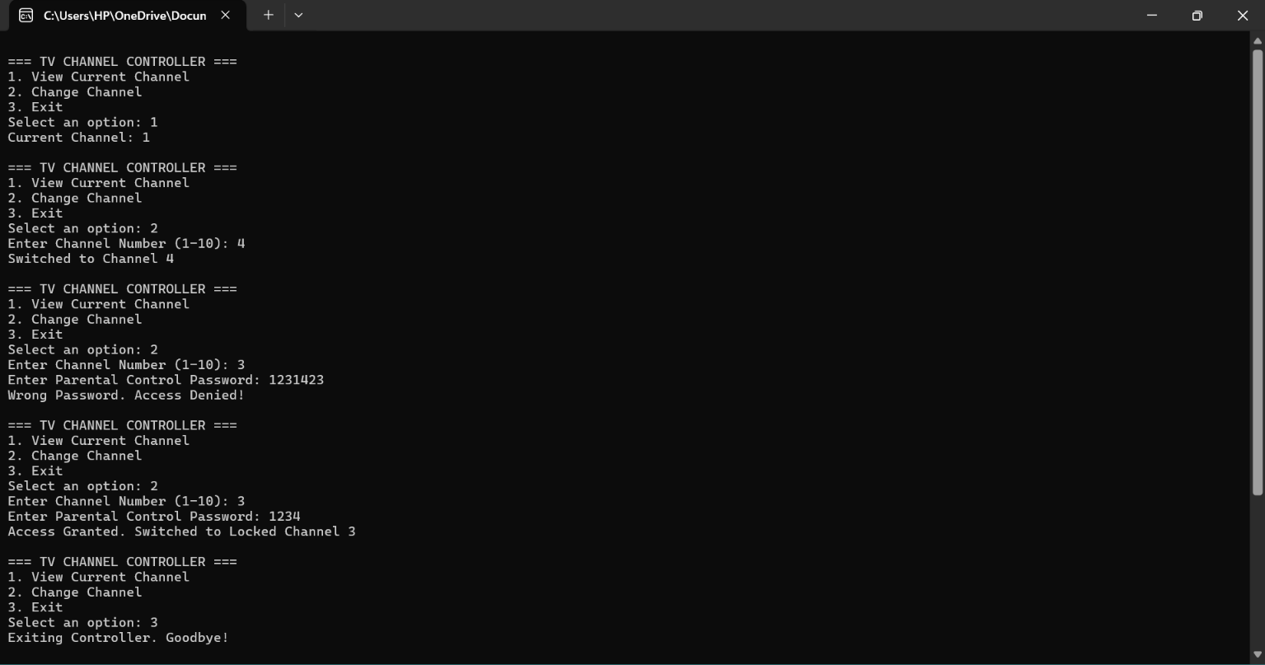

WEEK 6: FINALIZATION, DOCUMENTATION, AND DEMONSTRATION

Overview:
The final week involved polishing the project, preparing documentation, and presenting the fully functional prototype.

Key Learning Areas:
- Embedded project documentation and commenting standards

- User manual preparation

- Demonstration techniques for showcasing features

Practical Tasks:
  - Created complete user and developer documentation

  - Built a final demo board/prototype with all functionalities

  - Presented system workflow, code explanation, and feature highlights

  - Added future enhancement suggestions like app-based control.

Skills Developed:
  - Technical documentation and user guide writing

  - Embedded project demonstration skills

  - Presentation of embedded features to technical and non-technical audiences.

CHAPTER 5

CONCLUSION

My internship at Suresoft Systems Pvt Ltd has been an invaluable and transformative phase in my academic and professional journey. Specializing in embedded system software development, this experience provided me with a comprehensive understanding of how embedded technologies are applied in real-world industrial settings. From working closely with microcontroller architectures to writing and optimizing Embedded C code, I gained hands-on experience in creating software solutions that interact directly with hardware components, which has greatly enhanced my technical depth.
One of the key highlights of this internship was the opportunity to contribute to a project involving the decoding of IR signals and implementing control logic through interrupt-driven routines. I learned how to configure and use hardware timers, set up UART communication for real- time feedback, and structure embedded applications using modular design principles. This experience taught me the importance of system reliability, resource management, and timing precision, which are vital in embedded environments.
Furthermore, the structured project execution process at Suresoft—starting from requirement analysis and firmware development to simulation and testing—helped me understand the complete lifecycle of an embedded software project. Tools such as Keil for programming and Proteus for simulation provided practical exposure to the development and debugging processes typically used in professional embedded system design.
Equally important was the professional exposure to collaborative development. I participated in team discussions, code reviews, and milestone evaluations that helped me improve not only my technical capabilities but also my ability to communicate and justify design decisions effectively. I gained an appreciation for coding standards, documentation practices, and maintaining version- controlled repositories, all of which are essential for maintaining consistency and clarity in team- based development environments.

This internship also reinforced the importance of testing and validation in embedded systems, especially for applications in consumer electronics and safety-critical domains. I learned to design robust code that could handle real-time constraints and hardware uncertainties, and to build systems that are both scalable and maintainable.
Overall, this internship at Suresoft Systems Pvt Ltd has solidified my interest in embedded systems and laid a strong foundation for my future career in this domain. It allowed me to bridge the gap between academic learning and industrial application, while cultivating a problem-solving mindset and a strong technical skill set. As I move forward, I carry with me not just technical knowledge, but also the confidence and adaptability required to thrive in the fast-evolving field of embedded software development.

